- Label the bones of the Thoracic and Pelvic Limb.
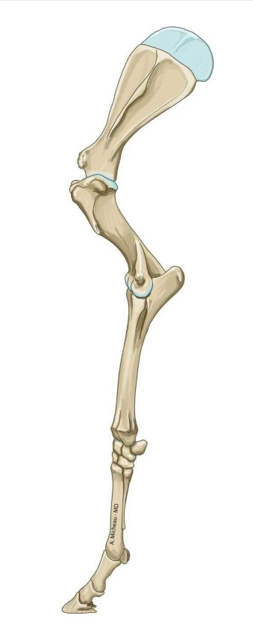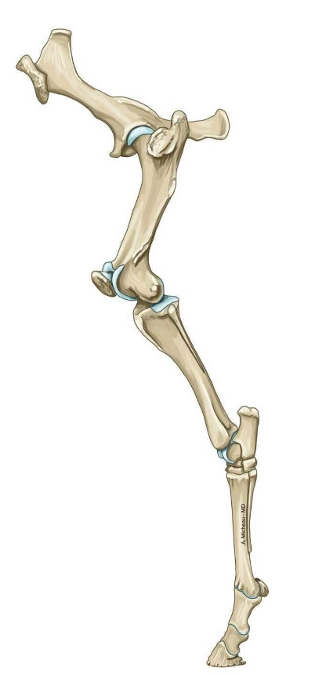

- Write out the process for intramembranous ossification.

- Write out the process for endochondral ossification.

- What are the two hormones that regulate bone growth.

- What type of tissue is bone?

- What are the functions of bone?

- Name the types of bones and give an example of each.

Match
Diarthroses Immoveable

Amphiarthroses Freely moveable

Synarthroses Slightly moveable

